DEPARTMENT OF COMMERCE & MANAGEMENT

SL.NO | DETAILS OF THE EVENT
1. | Title of The Event | AI-Powered Industry Readiness & Career Acceleration
2 | Day and Date | 07/04/2026
3 | Venue | TOCSAM- Auditorium
4 | Organizing Secretary/ Co-Coordinators | Dr. Praveen Kumar Sinha
5 | Resource Person With all details | Mr. SM Dutta
6 | Participants | Final Year BBA, BCOM & BCA
6 | No of Student and staff present | 80 students + 7 Faculty

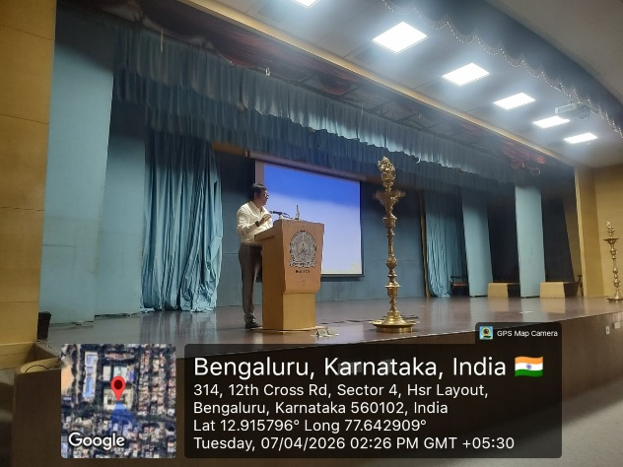 | 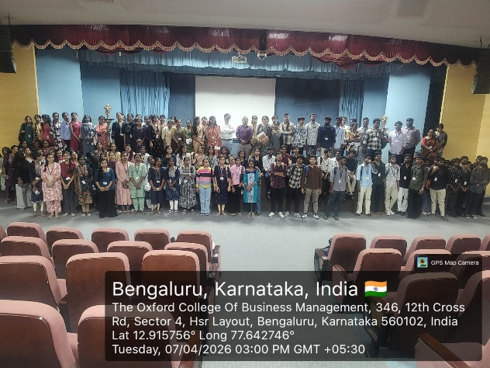

On April 7, 2026, the Department of Commerce and Management at The Oxford College of Business, Arts, Commerce & Management held a compelling technical session in the college auditorium titled "AI-Powered Industry Readiness & Career Acceleration." Addressing an engaged audience of BBA, B.Com, and BCA students, the keynote speaker highlighted how the professional landscape of 2026 has shifted from linear career paths toward a data-driven, continuous feedback loop. The session explored how agentic AI systems now allow candidates to pinpoint specific "skill gaps" in real time, enabling hyper-personalized upskilling that bypasses traditional, static curricula. By adopting these AI-driven career acceleration strategies, students were shown how to use AI as a force multiplier—mastering a "human-AI hybrid" workflow that automates routine tasks to focus on high-level strategic judgment and leadership.

Coordinator HOD Vice-Principal Principal

